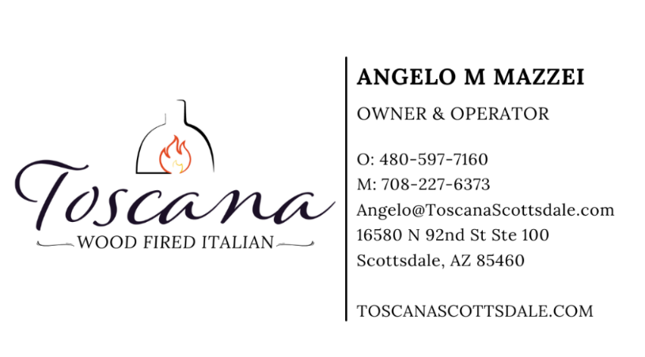

Small Plates• Shareables
Burrata- Melted burrata cheese from Italy, confit tomato, garlic, basil, EVOO, offered with ciabatta toast points 16
Our Salad- Spring mix, carrot, celery, fennel, imported sundried tomatoes, artichokes, parmigiano, house balsamic 12
Octopus- Poached, and plated with olives, fingerling potatoes, Calabrian chili romesco, basil pesto, pickled vegetables, celery leaf 16
Zucchini- Charred in our wood oven, mint, EVOO, pecorino cream, balsamic reduction 12
Caponata- Sweet red peppers, olives, eggplant, celery, onion, golden raisin vinified tomato, ciabatta toast 12
Arancino- Saffron arborio rice ball that is stuffed with pomodoro sauce, peas, cheese, coated with breadcrumbs, basil garnish 12
*Beef Carpaccio- Paper thin filet mignon, fried capers, parmigiano, artichoke, arugula, mustard aioli, charred lemon, ciabatta toast 16
Chilled Seafood Salad- Shrimp, calamari, celery, EVOO, garlic, lemon zest, sweet red peppers, blood orange, fennel, parsley, squid ink chips 16

Bread Service - 10
House made focaccia and ciabatta served with EVOO and balsamic reduction

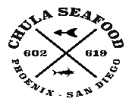

*Consuming under cooking meat, fish, or poultry can increase your risk of food bourn illness.

Pasta • Panini• Et Cetera
Gnocchi- Chef’s handmade potato pasta, peas, wild mushrooms, melted stracciatella cheese, breadcrumbs, crispy sage 24
Shrimp Pesto- Imported “guitar sting” pasta, Sea of Cortez shrimp, basil pesto, pine nuts, parmigiano 28
Pomodoro- Imported “guitar string” pasta, San Marzano tomato, garlic, basil, EVOO, parmigiano 22
Amatriciana- Bucatini pasta, San Marzano tomato, guanciale, pecorino, parsley, basil, red onion 25
Bolognese- Imported Paccheri pasta, braised prime cuts of beef, Duroc pork, herbs, Barolo wine reduction, bechamel, parmigiano, San Marzano tomato 28
Burrata Panino- Imported burrata, arugula, sundried tomatoes, on toasted our ciabatta bread, house dressing, side of crispy potatoes 20 add prosciutto +6
*Filet Medallions- Cast iron seared, Barolo wine sauce, arugula salad garnish, offered with sauteed Swiss Chard and crispy potatoes 30
Porchetta Panino- Wood oven roasted pork, heirloom polenta, cherry mostarda, pickled veggies, on ciabatta bread, side of heirloom polenta 22
Vesuvio- Half organic Mary’s Heritage chicken roasted in our wood oven, lemon, garlic, herbs, peas, chicken au jus, crispy potatoes 28
Branzino- Pan seared European Striped Bass, tomato herb vinaigrette, offered with a side of sauteed spinach 34
Accompaniments - 8 each
Wild Mushrooms/Creamy Heirloom Polenta Crispy Potatoes/Roasted Rainbow Cauliflower Braised Swiss Chard/Sauteed Spinach

Our wine list is curated by a sommelier, certified by the Court of Master Sommeliers

6oz glass 15 bottle 55
SPARKLING
Moscato D’Asti | Borgo Maravgliano Prosecco/Glera- Valdobbiadene | Ruffino NV Pinot Noir- Veneto | Le Contesse Rosé Lambrusco- Emilia Romagna | Donelli
WHITE
Chardonnay- Central Coast, CA | Clos LaChance
Falanghina- Campania | Fontanavecchia
Pecorino- Abruzzo | Agricosimo
Pinot Grigio- Friuli-Venezia | Borgo Boschetto
Riesling- Mosel, Germany | Trullo
Rosé- California | Hogwash (only by the glass)
Rosé- Toscana | Dogajolo
Sauvignon Blanc- Marlborough, NZ | Hooks Bay
Sauvignon Blanc- Sancerre | Domaine Serge LaPorte
RED
Cabernet Sauvignon- Napa | N.A.P.A.
Cabernet Sauvignon- Toscana | Erastos
Corvina Blend-Luciano Arduini “Ripasso”
Montepulciano D’Abruzzo- Agricosimo “Scine”
Nebbiolo- Langhe | Dezzani
Pinot Noir- Willamette Valley | Buttler Hill
Chianti Classico | Tenuta Nozzole
Super Tuscan Blend- Toscana | Isabella
BEER
Blue Moon 6 Church Music (draft) 8 Coors Light (draft) 6 Four Peaks Kilt Lifter 7 Guiness 7 Heineken Zero 6 La Fin Du Monde 8 Michelob Ultra 6 Peroni (draft) 7 Stella Artois 7

LIBATIONS - 18
Summer in Toscana: Ketel Grapefruit, Italicus, Elderflower liqueur, fresh grapefruit juice, Campari float, basil leaf
Italian MAN: YellowStone Toasted Bourbon, Montenegro Amaro, sweet vermouth, bitters, Luxardo cherry
Sicilian Lemon Drop: Limoncello, blood orange liqueur, vodka, lemon lime soda, lemon sugar rim, lemon wheel
Dante in Repose: Tuaca, grappa, Luxardo cherry liqueur, lemon juice, fig syrup, sage leaf
Spritz: Lambrusco or Prosecco, Aperol, club soda, fresh orange peel
If Leo were Cosmo: Blood Orange house infused vodka, cranberry elixir, orange liqueur, lime juice, lemon wheel
Michelangelo’s Midnight Oil: Espresso, vanilla vodka, Frangelico, chocolate cream, sugar rim
MOCKTAILS- 10
Raspberry Fizz- Pellegrino, lemon juice, REAL raspberry puree, sage leaf
Pineapple Punch- Cranberry juice, REAL pineapple puree, fresh squeeze orange juice, Panna water, almond bitters, orange peel
Cherry Limeade- Luxardo cherry juice,lime juice, Panna water, cherry
Cucumber Mash- Muddled cucumber and mint, agave syrup, Pellegrino, lemon bitters, cucumber slice

